|  |  |  |
| --- | --- | --- |
| ***SERVICES*** | Water Technology SERVICES A DIVISION OF  **Osmosis Technology & Engineering Company** | ACN: 622 208 753 ABN: 99 241 264 466 299A Canterbury Rd Revesby NSW 2212 Australia Tel: 1300309049  E-mail: info@osmotec.com.au Website: www.osmotec.com.au |

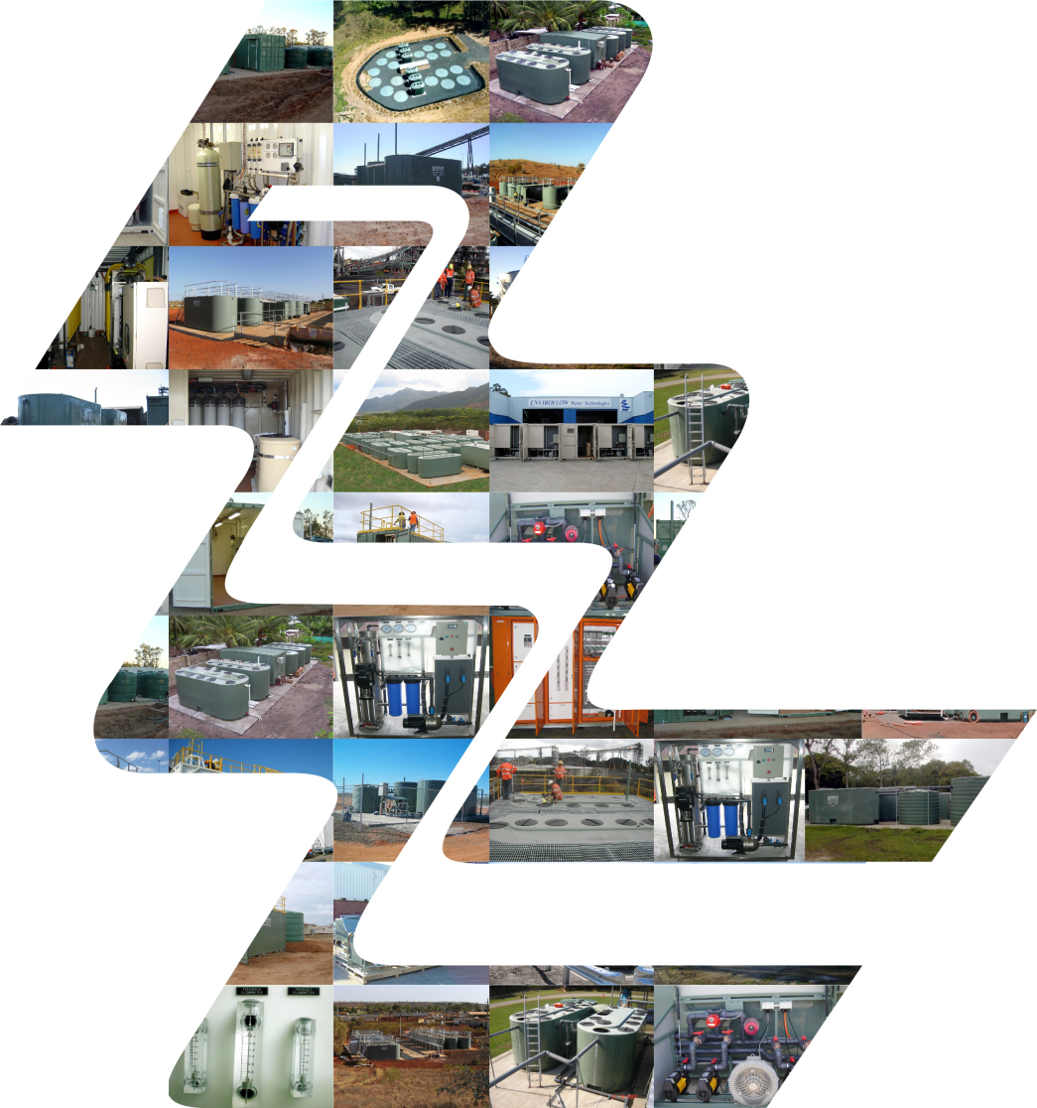

**Attention: Michael Lundin**

**YOUR OSMOTEC SErVICES CONTACT: Liam Farrell**

# **QUOTATION No. BWRO/14190**

# Prepared For:

# 

**Australian Botanical Company (ABC)**

# Kingaroy Project – 30 KLD PWTP

Brackish Water Reverse Osmosis Plant

# Table of Contents

1. OVERVIEW 3

2. Specific Design Parameters 3

3. Variations and Potential Impact 4

4. Potable Water Treatment Plant Characteristics 4

5. Proposed Potable Water Treatment Plant Equipment 5

6. OSMOTEC Services Scope of Supply/Works 10

7. Client Scope of Supply/Works 11

8. Commercial 12

9. Conclusion, Benefits of the OSMOTEC Services Package 14

## 

## OVERVIEW

Osmotec Services is pleased to submit this proposal to provide design, manufacture and commissioning services for the installation of a new water treatment plant located at Kingaroy QLD.

Australian Botanical Company’s CEO/Director has engaged Osmotec to assist in providing a technical design for a water treatment plant. The water treatment design is to treat onsite bore water to quality specifications allowing for onsite irrigation.

Osmotec specialise in the design, manufacture, installation and service associated with Water and Waste Water Treatment Facilities. It is assured that the following service or product offered by Osmotec is based on many years of practical and proven experience.

BASIS OF PROPOSAL

This proposal is based on information provided to Osmotec from ABC; at this stage, information is limited to the following.

* Estimated Water Throughput – Up to 30kL/day.
* Up to 75% depending on Raw Water Feed Quality & Water Temperature
* Flowrate based on treated water required for onsite irrigation.
* Water Quality – Reduced Dissolved Solids / Recyclable (Irrigation Etc.).
* Process Design Portions – Media / Micron Pre-filtration / Reverse Osmosis

Additional works outside this proposal or modifications to existing equipment affecting the design of the proposed packaged plant may require a review and additional cost may incur.

DESIGN PHILOSOPHY

The proposed design is based on the following criteria:

* Demineralised Water (TDS < 100 ppm) / Bore Water – Blended Output for Irrigation.
* Reverse Osmosis Pre-Filtration
* Automatic Operation
* Ease of Installation and Commissioning Requirements
* Reliability and Reduced Maintenance
* Low Energy Consumption
* Minimal Operation and Running Costs

## Specific Design Parameters

This project requires a Potable Water Treatment Plant (PWTP) to produce potable water located in Kingaroy, Queensland.

Hydraulic flow calculations for the plant are as follows:

* Maximum daily flow of 30,000L.

A water analysis has been provided and the proposed plant is based on this information. The chosen process will utilise Media Filtration, Cartridge Filtration and Reverse Osmosis.

## Variations and Potential Impact

As limited information is available at this stage of the project, OSMOTEC Services has assumed its own criteria for design of the proposed plant. There are a number of factors which would alter this design, with each potentially having a different impact on performance and commercial, these are:

* **Water Quality:** Should a water analysis be provided, and the source water be different to what has been assumed, this could result in changes being required to the proposed plant. This could be additional pre-filtration requirements, flocculent dosing requirements or higher-pressure RO membranes. This would likely have commercial impact on the proposed unit.
* **Flow Rate:** Should the nominated flow rate of 30 kL/day not be suitable the units would need to be resized. This would have commercial impact on the plant, however; whilst an increase in flow rate would require a larger system and increase in commercial, should a lower flow rate be acceptable the reverse would apply being a smaller more cost-efficient unit.

## Potable Water Treatment Plant Characteristics

### HOUSING OF PLANT

OSMOTEC Services specialises in the manufacture of water treatment equipment housed within one standard 20’ ISO container.

These containers are refurbished and include the following equipment:

* Ventilation as required– which provides ideal operating conditions for the filtration equipment. This also provides a comfortable work environment for operators whilst they are inspecting plant operation or carrying out maintenance on the equipment.
* Workbench as required – to provide an area for a laptop (if telemetry or software is used for overseeing plant operation), an area for tools and laying out drawings or manuals whilst working within the area.
* Bunded floors as required – to seal the container from any water leaks, thus ensuring longer life of the equipment. Also, the floor provides a safer work area - due to its non-slip properties.
* Overhead fluorescent lighting as required – these lights provide a safe working area, ensuring enough light for the operator to safely work in the area. These lights are installed on a separate circuit to the potable water treatment plant, thus allowing the lights to operate whilst the treatment plant is shut down for maintenance.
* 240V GPO power points as required – Two of these are provided to allow power tools, laptop etc to be connected whilst inside the plant room.

The proposed packaged pre-tested potable water treatment filtration and control room allows OSMOTEC Services technicians to pre-construct the total plant and test run the plant in our workshop. This factory pre-test has two major advantages:

* It assures the plant is “bug free” on arrival to site and
* This dramatically decreases on-site time and labour which is a massive cost advantage to our clients.

## Proposed Potable Water Treatment Plant Equipment

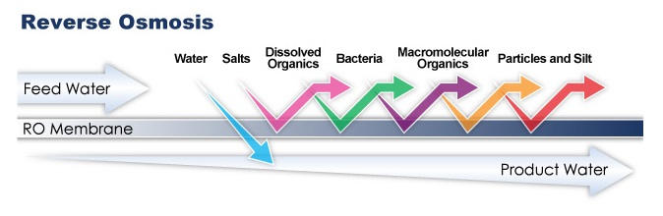

**System Inclusions – Reverse Osmosis Plant**

**Item One** – OSMOTEC Specified - Skid Mount Reverse Osmosis System – 30kL/day

System – RO Plant Specifications

Please note: This option is purely system supply only and does not include any allowance for installation, commissioning and system integration / automation.

* Plant Peak Performance at < 25°C, < 2000ppm TDS, < 5 NTU Turbidity.
* Recovery Rate - 50 to 75% Depending on Raw Water Feed Quality & Water Temperature
* Operating Pressure - 900kpa – 1600kpa
* Inlet Water Pressure - 280kpa minimum – 500kpa maximum
* Typical Ion Rejection - 95% to 98%
* Membrane Housing - (12) x 4.0” x 40” 300psi Fibreglass Housing End Entry
* Membrane - (12) x 4.0” x 40” TFM
* Membrane Model - Hydranautics: CPA5-LD-4040
* Array - 4-4-2-2 (1 Element per Housing)
* Pump - Multi-Stage Centrifugal 304 SS Pump
* Motor - 380/415VAC/50Hz – Starting Method D.O.L
* High Pressure Piping - Pressure U-PVC Pipe
* Electrical Panel - IP65 Cabinet with Mains Isolator + Panel indicators
* Skid Frame - Stainless Steel – Painted
* Pre-treatment Filter - P.V.C. Housing 30” x 5 Round Cluster
* 20’ Shipping Container – Bonded Liner
* Split System – Reverse Cycle AirConditoner

System Feed – Raw Bore Water Quality & Treated Water Quality Prediction.



System – RO Plant Membrane / Fluid Stream Configuration





**System Inclusions – Reverse Osmosis Plant – 30kL/day**

**Item Two** – Reverse Osmosis Pre-Filtration + Automation Package.

**Pre-Filtration Package -** Equipment inclusive of the following

(External to Skid Mount RO Plant).

* Raw Water Multistage Feed / Backwash Pump 350kPa App.
* Variable Area Flow Rotameters
* Fibreglass Multimedia Filtration Vessel 24x72” / 4” Top.
* Turbidex Gravel / Sand
* Electrically Actuated Alternating Flow Path System
* Micron Filtration Bag Filter Vessel / Multicluster
* Analogue Pressure Gauges
* UPVC / HDPE Pipework + Support Systems

**RO-Plant Automation Package -** Equipment inclusive of the following

(External to Skid Mount RO Plant).

**Control System**

* Electrical Control Cabinet - IP66 Mild Steel
* PULS Power Supply - CT5.241
* Panasonic PLC FPXC30RD
* Panasonic PLC Expansion AFPX-EFPO
* Panasonic PLC Expansion ADC-8CH
* Panasonic PLC Expansion DAC-4CH

**Variable Frequency Drives**

* Feed Pump / Low Pressure Variable Speed Drive - 2.2kW
* Feed Pump / High Pressure Variable Speed Drive - 5.5kW
* Flex VSD Screen 3C+E 2.5mm PVC/EMC/PVC Clear
* EMC Cable Gland M20 13-17mm IP66
* Advanced VSD Display Pads

**System Analyticals / Chemicals Dosing Equipment**

* Electro-Magnetic Flow Meters (Feed Backwash / Permeate / Reject).
* pH High + pH Low + AntiScalant Dosing Pumps (Citric Acid / Caustic Soda / Hydrex).
* pH /Temp Instrumentation - (Transmitter + pH/Temp sensors).
* Straight Port - Electric Actuating Valves (Media Backwash CIP Cycles).
* T-Port or L-Port - Electric Actuating Valves
* Dekron Unarmoured Instrumentation cable.
* Mechanical supports (Cable Ladder / Brackets Etc).

**RO-Plant –** Excluded Items

* Any infrastructure, Civil, Electrical and Plumbing works associated with the

Reverse Osmosis Plant Installation

* Any support structures, handrails, walkways, weather shelters and gantries
* Any Concrete Slabs / Level Pads required for Containers and or support structures.
* Any underground electrical cable support systems (Conduits / Pits / Marshall Boxes).
* Any Electrical Supply Equipment (Mains / Submains / Distribution Panels).
* Any Outside / External Lighting and Cabling
* Any Safety Equipment, such as Signage / Safety Showers / Chemical Bunds

**Pre-Filtration Package -** Excluded Items

* Any infrastructure, Civil, Electrical and Plumbing works associated with the

Pre-Filtration Installation

* Any support structures, handrails, walkways, weather shelters and gantries
* Any Concrete Slabs / Level Pads required for Containers and or support structures.
* Any underground electrical cable support systems (Conduits / Pits / Marshall Boxes).
* Any Electrical Supply Equipment (Mains / Submains / Distribution Panels).
* Any Outside / External Lighting and Cabling
* Any Safety Equipment, such as Signage / Safety Showers / Chemical Bunds
* **Any supply of chemicals (Chemical can be supplied upon client’s request).**

**Automation Package** - Excluded Items

* Any infrastructure, Civil, Electrical and Plumbing works associated with the

Automation Installation.

* Any support structures, handrails, walkways, shelters and gantries
* Any Concrete Slabs / Level Pads required for Containers and or support structures.
* Any underground electrical cable support systems (Conduits / Pits / Marshall Boxes).
* Any Electrical Supply Equipment (Mains / Submains / Distribution Panels).
* Any Outside / External Lighting and Cabling

**Additional Exclusions**

Additional infrastructure, materials, services and or works outside this proposal or modifications to existing equipment affecting the design of the proposed packaged plant that has not been specifically listed within this proposal document, is considered an excluded item and will not be supplied by Osmotec Services.

The Potable water treatment plant is designed on the following criteria:

Capacity of plant – 30 kL/day potable treatment plant, Influent analysis –**Provided**

The major equipment’s are listed in the below Table.

|  |  |
| --- | --- |
| **Parameters** | **General Info** |
| Reverse Osmosis Unit | Hydranautics CPA Membrane or similar |
| RO Vessels | Codeline, 300 psi |
| Reverse Osmosis Skid System | 4:1 Array |
| Carbon Steel Skid | Epoxy & Powder Coated |
| CIP System (RO) | Semi-Automatic |
| Multimedia Filtration | Maxflow or similar |
| Cartridge Filter | 5 & 1 microns |
| Dosing Units | Antiscalant, Acid, Caustic |
| Online Monitoring | pH, TSS, TDS, Chlorine, Turbidity |
| ORP Monitor | GF-2750 |
| TDS Monitor | GF-2850 |
| Electrical PLC / HMI control system | GSM or wireless Internet compatible |
| HP RO Pumps | Grundfos CRN 20-10, 11 kW |
| HP Piping | 316 SS |
| uPVC Piping | Sched. 80 (LP piping) |
| FIT | GF-2537 |
| Air conditions 20’ container | Fitted out & FAT tested |

## OSMOTEC Services Scope of Supply/Works

|  |  |
| --- | --- |
| **Item No.** | **Description** |
| **1** | Design and manufacture one potable water treatment plant as described above |
| **2** | Provide all control boards and systems for the plant operation. Electrical to AS/ NZS 3000 : 2007, all wiring to AS3000. |
| **3** | Install safety alarm requirements (via flashing lights) |
| **4** | OSMOTEC Services technician to supervise the installation of supplied plant |
| **5** | On site training of suitable client maintenance and operation staff |
| **6** | Training, maintenance and operation manuals – 2 sets |
| **7** | Fresh water commissioning of plants on site |
| **8** | To produce installation drawings consisting of plant, hydraulic and electrical layouts and conceptional footprints – 2 sets |
| **9** | Loading of plant at Brisbane workshop and transport to site – if optioned |

## Client Scope of Supply/Works

|  |  |
| --- | --- |
| **Item No.** | **Description** |
| **1** | Clean “Raw” water for commissioning of the plant |
| **2** | Provide connection of power supply to all OSMOTEC Services control boards, field wiring, and power for installation |
| **3** | Supply suitable cranage on site to remove the plants from transport and position on concrete slab |
| **4** | To provide raw water and product water tanks |
| **5** | Transport from manufacturing facility to site for installation – TBA |
| **6** | Provide suitable staff for on-site training of plant operation and maintenance, preferably an electrician a plumber and site maintenance manager |
| **7** | To supply and install a concrete slab or compact earth base to support the proposed treatment plants |
| **8** | Government charges, duties, taxes, landscaping, security and fencing as required |
| **9** | Access to site for all OSMOTEC Services commissioning personnel, required on site |
| **10** | Cover any costs associated with any site inductions which may be required for commissioning personnel |
| **11** | Provide suitable water disposal system for reject water from treatment plant |
| **12** | Provide 25 mm potable tap beside slab area for safety and maintenance requirements |
| **13** | Supply travel, transfers, accommodation and meals for technician as required |

## Commercial

**System Price Projection**

Pricing for the scope as described throughout this proposal document is as shown below.

Osmotec Services is offering to provide equipment with optional installation and commissioning services to assist with the installation of the Reverse Osmosis Plant.

Pricing reflects a Reverse Osmosis Treatment Plant capable of treating up to **30kL/day**.

|  |  |
| --- | --- |
| **Project** – Kingaroy QLD – Water Treatment Plant / Reverse Osmosis 30kL/day.  **Client** – Australian Botanical Company / Contact Person – Michael Lundin | |
| **Description of Goods and Services** | |
| **Item 1 - Supply of Reverse Osmosis Pant (Package Plant) – 30kL/day plant.**  Supply all associated Equipment listed previously within this proposal document.  **Item 2 - Supply of Reverse Osmosis Pant (Package Plant) – 50kL/day plant.**  Supply all associated Equipment listed previously within this proposal document.  **Item 3 - Supply of Reverse Osmosis Pant (Package Plant) – 100kL/day plant.**  Supply all associated Equipment listed previously within this proposal document.  Electrical + Instrumentation Technician - $125.00/Hr  Plumbing + Hydraulics Technician - $115.00/Hr  Transport costs, accommodation and meals to be supplied by client. | |
| **Pricing may change if; client requests additional design/project specifications.** | |
| **Supply of Reverse Osmosis Pant (Package Plant) – 30 kL/day plant** | $97,890 + Gst |
| **Supply of Reverse Osmosis Pant (Package Plant) – 50 kL/day plant** | $124,360 + Gst |
| **Supply of Reverse Osmosis Pant (Package Plant) – 100 kL/day plant** | $147,890 + Gst |
|  | |
| Please note: System pricing is supply only, this does not include installation and commissioning cost, please refer to Schedule of rates above. | |

### Payment Terms

|  |  |  |
| --- | --- | --- |
| Mobilisation: | 35% | Of contract price payable on placement of order. |
| Progress Claim: | 60% | Of contract price claimed monthly (in portions) and invoiced up to dispatch date.  Payable 14 days from invoice date. |
| Final Claim: | 5% | Final balance of contract price within 30 days of delivery to site OR within 7 days after clear water commissioning/practical completion (whichever occurs first). This will be subject to OSMOTEC Services completion of the documented scope of works and advice that all components are installed and in an operational or stand-by mode.  Payable 14 days from invoice date. |

### Delivery

This plant is a purpose built design and requires a certain amount of fabrication to meet the site-specific requirements on site. As such, a delivery period (from workshop, Brisbane) is approximately 12 - 14 weeks from receipt of order and mobilisation monies, depending on workshop availability and scope of supply.

### Warranty Details

A full six (6) month manufacturers warranty applies to all working parts from the date of despatch.

Replacement parts will be supplied when approved for warranty by the manufacturer. Cost for the freight and installation of the parts will be the responsibility of the Client.

The above warranty covers material defects, however, excludes the following:

* Damage to the equipment by the Client.
* Poor performance arising from the incorrect operation of the Plant or equipment by the Client (e.g. overloading).
* Poor performance arising from power interruptions and/or surges.
* Influent quality varying from the expected quality as detailed above.
* Sewage suffering from high hardness waters.

### Validity

This quotation is valid for a period of thirty (30) days from the date of this quotation. OSMOTEC Services reserves the right to adjust pricing after this date to reflect any market price variances.

### Terms and Conditions of Sale

OSMOTEC Services Terms and Conditions are applicable for this quotation supplied. These conditions are attached.

### Commissioning

Commissioning of the plant will be carried out at the completion of the plant installation. Commissioning for some plants requires two site visits. The first, to commence the biological process and the second to fine tune or balance the biological process and initiate the membrane activity where class “A” or membranes are applicable

Should this not occur due to circumstances beyond OSMOTEC Services’ control the client will be responsible for the return visit and subsequent costs. If an extended delay is envisaged the pumps and affected components must be removed stored and/or protected from damage as per the operator’s manual.

The commissioning will include:

* Electrical connection of internal equipment to the control panel, all field wiring and main connection by others.
* Installation and testing of pumps.
* Instruction of relevant suitable personnel on the operation of the OSMOTEC Services plant at the time of clear water commissioning.
* Operation and maintenance manual.
* Outline basic on site training.

## Conclusion, Benefits of the OSMOTEC Services Package

* The proposed treatment plants incorporate the latest technology for the treatment of water, providing outstanding final water quality.
* The proposed water treatment plant is housed within a 20’ ISO shipping container, thus making site installation rapid and hassle free.
* The plants contain minimal electro-mechanical components that allow for simple operation and maintenance - therefore a highly skilled operator is not required.
* OSMOTEC Services is the leader in the field of packaged treatment plants. Our systems are constructed to rigorous standards and consistently surpass the design parameters currently recognised in Australia and worldwide to ensure the highest level of performance.
* The treatment plants are specifically designed to suit the rigours of the climatic conditions expected on site.

We would appreciate the opportunity to discuss our proposal with you and welcome any further inquiries that you may have.

Kind regards

Liam Farrell

**OSMOTEC Services Water Technologies**

299A Canterbury Rd  
Revesby NSW 2212 Australia  
Tel: 1300309049

E-mail: info@osmotec.com.au  
Website: www.osmotec.com.au